**CHANDIGARH UNIVERSITY**

**GHARUAN**

**BACHELOR OF TECHNOLOGY**

**IN**

**COMPUTER SCIENCE & ENGINEERING**

**A**

**PROJECT REPORT**

**FILE**



**ONLINE EXAM SYSTEM**

**SUBMITTED BY:**

**CHANDAN (15BCS2244)**

**ANKITA (15BCS2240)**

**INDEX**

* Acknowledgement
* Certificate
* Introduction
* Software Development Methodology
* System Requirement Specification
* Introduction

*Purpose

*Scope

*Abbreviations

* + References
  + Overview

*Overall Description

*Product Perspective

* + 1. System Interfaces
    2. User interfaces
    3. Hardware interfaces
    4. Software interfaces
    5. Communications interfaces
    6. Memory constraints
    7. Operations
    8. Site Adaption Requirements

* + Product functions
  + User characteristics
  + Constraints
  + Assumptions and Dependencies
  + Apportioning of requirements

*Specific requirements

*External interface requirements

* User interfaces
* Hardware Performance requirements
* Design constraints
* Software system attributes
* Security
* Maintainability
* Portability
* Logical Database Requirements
* Other requirements
* DFD
* ERDIAGRAM
* Problem Description & Scope
* Hardware & Requirement
* Analysis & Report of the Present Manual System

## ACKNOWLEDGEMENT

We gratefully acknowledge for the assistance, cooperation, guidance and clarifications provided by **CHANDIGARH UNIVERSITY** during the development of the **OnlineExams System** website. Our extreme gratitude to **Mrs. Hatesh** who guided us throughout the project. Without her willing disposition, spirit of accommodation, frankness, timely clarification and above all faith in us, this project could not have been completed in due time.

Her readiness to discuss all-important matters at work deserves special attention. We would also like to thank whole of the faculty of the college for their cooperation and important support.

## 

## CERTIFICATE

This is to certify that “**Ankita Sinha** and **Chandan Walia**” have developed the project entitled “**Online Exam System”.** He has worked on the project Online Exam System. He has used HTML, JSP, JAVASCRIPT and MS.ACCESS as Database for the project. Their work is satisfactory.

I wish them all the best for their bright future.

## INTRODUCTION

***OnlineExams*** is being launched because a need for a destination that is beneficial for both institutes and students. With this site, institutes can register and host online exams. Students can give exams and view their results. This site is an attempt to remove the existing flaws in the manual system of conducting exams.

**Purpose:**

***Online Exams System*** fulfills the requirements of the institutes to conduct the exams online. They do not have to go to any software developer to make a separate site for being able to conduct exams online. They just have to register on the site and enter the exam details and the lists of the students, which can appear in the exam.

Students can give exam without the need of going to any physical destination. They can view the result at the same time.

Thus, the purpose of the site is to provide a system that saves the efforts and time of both the institutes and the students.

**What is Online Exams System all about?**

***Online Exams*** System is a web application that establishes a network between the institutes and the students. Institutes enter on the site the questions they want in the exam. These questions are displayed as a test to the eligible students. The answers enter by the students are then evaluated and their score is calculated and saved. The institutes to determine the passes students or to evaluate their performance can access this score then.

***Online Exams System*** provides the platform but does not directly participate in, nor is it involved in any tests conducted. Questions are posted not by the site, but users of the site. The site requires an institute to register before posting the questions.

The site has an administrator who keeps an eye on the overall functioning of the system. The site gets revenue by charging the institutes each time they want to conduct the exam.

The system entitled “Online Exams System” is application software, which aims at providing services to the institutes and providing them with an option of selecting the eligible students by themselves. It is developed by using J2EE technology and related database.

### SOFTWARE DEVELOPMENT METHODOLOGY

The establishment and use of sound engineering principles in order to obtain economically developed software that is reliable and works efficiently on real machines is called *software engineering.*

***Software engineering***is the discipline whose aim is:

1. Production of quality software
2. Software that is delivered on time
3. Cost within the budget
4. Satisfies all requirements.

**Software process** is the way in which we produce the software. Apart from hiring smart, knowledgeable engineers and buying the latest development tools, effective software development process is also needed, so that engineers can systematically use the best technical and managerial practices to successfully complete their projects.

A **software life cycle** is the series of identifiable stages that a software product undergoes during its lifetime .A software lifecycle model is a descriptive and diagrammatic representation of the software life cycle .A life cycle model represents all the activities required to make a software product transit through its lifecycle phases .It also captures the order in which these activities are to be taken.

***Life Cycle Models***

There are various life cycle models to improve the software processes.

 WATERFALL MODEL

PROTOTYPE MODEL

ITERATIVE ENHANCEMENT MODEL

EVOLUTIONARY MODEL

SPIRAL MODEL

In the project, **Waterfall model** is followed.

### WATERFALL MODEL

**WATERFALL MODEL**

This model contains 6 phases:

* **Feasibility study:**

The feasibility study activity involves the analysis of the problem and collection of the relevant information relating to the product. The main aim of the feasibility study is to determine whether it would be financially and technically feasible to develop the product.

* **Requirement analysis and specification:**

The goal of this phase is to understand the exact requirements of the customer and to document them properly (SRS)

* **Design:**

The goal of this phase is to transform the requirement specification into a structure that is suitable for implementation in some programming language.

* **Implementation and unit testing:**

During this phase the design is implemented. Initially small modules are tested in isolation from rest of the software product.

* **Integration and system testing:**

In this all the modules are integrated and then tested altogether.

* **Operation and maintenance**:

Release of software inaugurates the operation and life cycle phase of the operation.

The phases always occur in this order and do not overlap.

#### Software Requirement Specification (SRS)

1. **Introduction:**

The following subsections of the SRS document provide an overview of the entire SRS.

* 1. **Purpose:** The purpose of the project is to provide online facility to *Institutes* to conduct online exams and to Students to give online exams. Institutes can enter and edit the questions along with the students list. Also they can view the result. Students can login and give their respective exams and view their score then and there. *Others* can view sample papers to get look and feel of the online examination system.
  2. **Scope:**  The website to conduct online examination is “**OnlineExams”.**This website provides facility to institutes to conduct online exams by providing a unique id to each institute. The institute provides questions along with positive and negative marks. Institute also enters the list of eligible students. The institute can later edit all the information entered.

In turn, student can login with their id, name, instituted to give the exams, and can view their result immediately. Institutes can also view the result of their students.

* 1. **Benefits:** This website reduces the manual work, maintaining accuracy, increasing efficiency and saving time. In addition, institutes need not go to develop a new software each time; instead, they just register and conduct a test. For students, it saves time of going too far away centers and they can view their result immediately.
  2. **Abbreviations:**  JSP stands for Java Server Pages

HTTP stands for HyperText Transfer Protocol

* 1. **Overview:** The rest of this SRS document describes the various system requirements, interfaces, features and functionalities in detail.

1. **Overall Description:** In Online, examination system institute can register to conduct a online test and view the records later. Students can give the test and their respective records, which include their marks for each test given by them, will be maintained separately. No student can take a particular exam more than once.
2. **Product Perspective:**

* *User interfaces:* The application will have a user friendly and menu based interface.

Following screens will be provided:

1. A login screen for entering the username, password will be provided. Access to different screens will be based upon the user.
2. There is a screen for displaying information regarding entries to be made by institutes.
3. There is a screen for displaying information regarding filling of exam details by institutes.
4. There is a screen for displaying information regarding entering student list for the particular exam.
5. There is a screen for displaying information menu regarding what options the institutes will select while filling entries (entering questions, student list, deleting questions, entering exam details).
6. There is a screen for displaying exam details to the students when they are taking exams.
7. There is a screen for taking exam for the students.
8. There is a screen for displaying of results of students after taking the exam.

* *Hardware interfaces:*

1. Screen resolution of at least 800X600 is required for proper and complete viewing of screens. Higher resolution will be accepted.
2. Support for printer for printing results immediately.

* *Software interfaces*

1. Any windows based operating system.
2. MS Access 2000 as the DBMS-for database.
3. IDE (NET BEANS) for developing code.

* *Communications interfaces*: None
* *Memory Constraints*

1. 512 MB RAM
2. 5 MB space on hard disk will be required for running the application.

* *Site Adaptation Requirements:*

Web browser with cookies enabled.

1. **Product Functions:** The website will allow access only to authorized users with specific roles (Administrator-maintains the website, Institutes-Register to conduct the exams, Students-Give the exams online).

A summary of the major functions that the website will perform:

* + 1. Provide facility to institutes to register to conduct a online test.
    2. Institutes can enter the number of questions, +ve, -ve marks, questions and answers and the list of eligible students.
    3. Students can login and give the tests.

**User Characteristics:**

* 1. Educational level: Users should be comfortable with the English language.
  2. Experience: Users should have prior information regarding the online examinations.
  3. Skills: Users should have basic knowledge and should be comfortable using general purpose applications on computers.

**Constraints:**

* + - Since the DBMS being used is MS Access 2000, which is not a very popular DBMS, it will not be able to store a very huge number of records.
    - Due to limited features of DBMS being used performance tuning features will not be applied to the queries and thus the system may become slow with the increase in number of records being stored. * An extra security as SSL must be used to secure the marks details and other examination information.

**Assumptions:** The examinations are all objective. Students can give each exam just once.

**Apportioning of Requirements:** The future versions of the website will be having a better database to handle larger number of records, in a more secure way. Also separate profile will be maintained later for all students so that he can view all his previous test performances.

**Specific Requirements:** This section provides software requirements to a level of detail sufficient to enable designers to design the system and testers to test the system.

* **External Interface Requirements:**

* User Interfaces:

**\*Institute Registration Screen:** Various fields available on this screen will be:

*Login Name

*Institute Name

*Email Id

*Password

**\*Institute Login Screen:** Fields available on this screen are:

*Login Name

*Password

**\*Entering Questions:** Various Fields are:

*Questions

*Options (4)

*Correct Answer

**\*Exam Details Screen:** Various Fields are:

*Exam Name

*No. Of Questions

*Time Limit

*+ve, -ve Marks

*Passing Marks

**\*Student List Screen:** Various Fields are:

*Student ID

*Student Name

**\*Student Login Screen:** Various Fields are:

*Student ID

*Student Name

*Institute ID

\***Student Taking Exam Screen:** Various Fields are: *Display Of Question With Options

*Control Buttons To switch questions

\***Result Displaying Screen:** Various Fields are:

*No. Of Correct Questions

*No. Of Incorrect Questions *No. Of Unattempted Questions.

*Total Marks.

*Result(Pass/Fail)

\***Hardware interfaces:**

*Support for printer for printing results then and there.

*Screen resolution of at least 800X600 is required for proper and complete viewing of screens. Higher resolution will be accepted.

\***Software interfaces:**

*Any windows based operating system.

*MS Access 2000 as the DBMS-for database.

*IDE (NET BEANS) for developing code.

\***Communications interfaces** None

* **Software Product Features:** 
  + Validity Checks:

Javascript provides validity checks for various fields in the forms.

* + Sequencing Information: All the information regarding exam details, student list, question details, display of result should be handled sequentially that is data should be stored only in a particular sequence to avoid any inconvenience
  + Error Handling: If any of the validations or sequencing flows does not hold true then appropriate error messages will be prompted to the user for doing the needful.

* **Performance Requirements:** This subsection specifies numerical requirements placed on the software or on the human interaction with the software, as a whole. Numerical requirements will include:

*300 terminals will be supported at a time

*Only text information will be supported(HTTP)

*All the transactions will be processed within seconds.

* **Design Constraints:**  None
* **Software System Attributes:**

*Security: Only authorized users will be able to access the website by entering the correct login name and corresponding password.

*Maintainability: The website can be maintained in present or future. It will be easy to incorporate new requirements in the individual modules.

*Portability: As the website is online so will be easily portable on various systems. The website will be also easily portable on any windows based system that has MSACCESS installed.

* **Logical Database Requirements:** The following information will be placed in the database:

*Organization Details: ID, Login Name, Email, Password, Institute Name.*Institute Exam Details: ID, Ename, Tlimit, Passmarks, No. Of Questions, Pmarks, Nmarks.

*Institute Student List: Sid, Sname, Egiven, Marks, Result.

*Institute Question Details:QID, Question, A, B, C, D, Answer.

* **Other Requirements:** None

##### DATA FLOW DIAGRAM

A DFD also known as ‘bubble chart’ has the purpose of clarifying system requirements and identifying major transformations. It shows the flow of data through a system. It is a graphical tool because it presents a picture. The DFD may be partitioned into levels that represent increasing information flow and functional detail. Four simple notations are used to complete a DFD. These notations are given below:

**DATA FLOW:** The data flow is used to describe the movement of information from one part of the system to another part. Flows represent data in motion. Information flows through a pipeline.



An arrow represents data flow.



**PROCESS:** A circle or bubble represents a process that transforms incoming data to outgoing data. Process shows a part of the system that transform inputs to outputs.



PROCESS

**EXTERNAL ENTITY:** A square defines a source or destination of system data. External entities represent any entity that supplies or receive information from the system but is not a part of the system.



EXTERNAL

ENTITY

**DATA STORE:** The data store represents a logical file. A logical file can represent either a data store symbol, which can represent either a data structure, or a physical file on disk. The data store is used to collect data at rest or a temporary repository of data. It is represented by open rectangle.



DATA STORE

**OUTPUT:** The output symbol is used when a hard copy is produced and the user of the copies cannot be clearly specified or there are several users of the output.



OUTPUT

**LEVEL ‘0’ DFD FOR ONLINE EXAMINATION**



RESULT

**EXAMINATIO**

**N**

**ADMINISTRATOR**

**INSTITUES**

**STUDENT**

**LEVEL ‘1’ DFD**



**QUESTION PAPER**

Register

enter

Enter

**INSTITUTE PROFILE**

manages

ready

enter

manages

use

**STUDENT**

**S RECORDS**

results

Authorized

**TEST RESULTS**

***REG***

***ISTER***

**INSTIUTES**

**REGISTERE**

**ADMINISTRT**

**OR**

***GIVE***

***EXAM***

**DISPLAY**

**OF**

**STUDENTS**

**LEVEL ‘2’ DFD FOR STUDENTS**

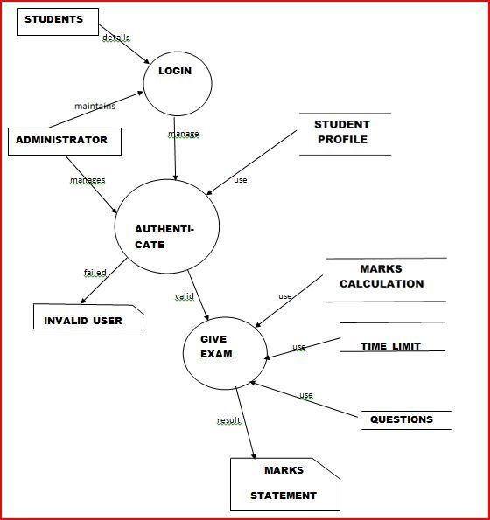

#### LEVEL ‘2’ DFD FOR INSTITUTES

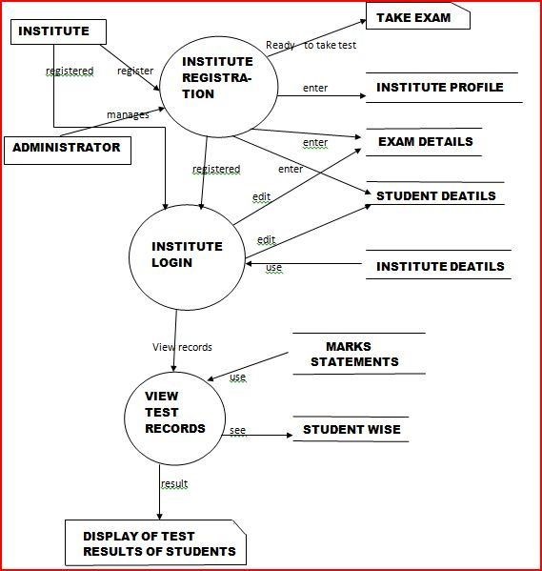

**PROBLEM DEFINITION**

A website, *ONLINEEXAMS*, is to be designed to conduct online tests. Unlike other online examination systems this website should not be just for the students, instead it should also provides facility to *Institutes* to host online Tests/Exams. This will help institutes as:

* There will be no need to get new software every time to conduct an online test.

Also like other online websites, it will help students by:

* Saving the extra time of going to far away Exam Centre.
* Students need not wait for their results.

Also this website will remove the flaws of existing Manual Systems like:

* Avoiding Mistakes Due To Human Error (Accurate).
* Reducing the manual labor (Decreases Overheads).
* Will Increase Efficiency and Save Time.
* Will Allow Neat Handling Of Data Rather Than Error Prone Records.

The institutes will register themselves with a unique login name and password; the unique Id will be issued to the institutes by the website.

After login:

* They will enter exam details like number of questions, +ve and -ve marks.
* Then they will enter the questions along with the answers, which can later be deleted and edited.
* In addition, they will enter the list of eligible candidates with their id names that can also be edited later.
* Institutes will be able to view the students list along with their respective results.

Also for students:

* They should be able to login with their id, name and instituted.
* They should be able to give the exam as per the details entered by respective institutes.
* In addition, they should be able to view their score after test finishes.
* If already given the test then they should just be able to view their scores.

Other users can take sample tests to get feel and look of how the online tests are conducted. Other key points:

* Different set of questions should be given to different students.
* The questions should be selected randomly from the database.

**FUNCTIONAL REQUIREMENTS**

It deals with the functionalities required from the system, which are as follows:

The website will help the colleges/organizations/companies to conduct their online exams.



Only authorized person can access related details.



The organization will register themselves on the website for conducting their exams.



Organizations can change their information regarding themselves.



The students can login through TEST-ID and PASSWORD and give their exams.



Administrator will be responsible for updating the site.



The organization can change questions and test papers whenever they want.



**The technologies used to develop this site are:**

**FRONTEND: (LANGUAGES)**

J2EE: Java 2 Enterprise Edition is a programming platform— part of the Java Platform for developing and running distributed multitier architecture Java applications, based largely on modular software components running on an application server.



HTTP: Hypertext Transfer Protocol is a transaction or oriented client/server protocol between web browser & a Web Server.



APACHE TOMCAT: Web-server for running j2ee applications over network.



HTML: HTML, stands for Hyper Text Markup Language, is a markup language



For web pages. It provides a means to create structured documents including headings, pictures, objects, lists, links, and other items and can be used to create interactive pages. It can include or can load scripts in languages such as JAVA

SCRIPT, which affects the behavior of HTMML processors like Web Browsers

**BACKEND: (DATABASE)**

MS-ACCESS: MS-ACCESS is used as a database.



 MS-ACCESS is a user-friendly user database with no special skills required to learn it.

 Database and tables in MS-Access are portable.

Users can create tables, queries, forms and reports, and connect them together with macros.

MS-Access is relatively compatible with SQL .Queries can be viewed graphically or edited as SQL statements.



**NON-FUNCTIONAL REQUIREMENTS**

They are the quality requirements that stipulate how well a software does what it has to do.

**Performance**



No. of terminals to be supported is dependent on the server that we will use at the time of deployment.

The web application server used should provide good performance and ability to manage performance with techniques such as support for caching.

After completing the exam, the entire score of the student will be calculated as per the rules in less than a second.

**Availability**



Online Examination site has 24*7 availability. It can be accessed for 24 hours a day. For this UPS support must be on the server site with a backup of at least 8 hours in case of power failure.

Students can take exam only during the previously allotted time slots, however can open site anytime to access other information. Colleges can register for the exam anytime.

**Reliability**



It means the extent to which program performs with required precision.

The website developed should be extremely reliable and secure so that information about any questions etc. is not leaked before the actual exam is held.

**Usability**



The website should be user friendly and should require least effort to operate.

The web server used should provide services like session management to maintain sessions in the application.



**Portability**



The website is made using HTML, JSP etc. which are platform independent and can be transported to other servers with minimum effort.

**Flexibility**



It is effort required to modify operational program. The whole website should be made using independent modules so that any changes done in 1 module should not affect the other one and new modules can be added easily to increase functionality.

**What contribution would the project make?**

This is an era of information technology where automation of each and every activity is gaining importance. The site will lead to the automation of the examination system. Moreover it is far better than the previous such websites.

**Computerized vs. Manual Examination System**

Automated process of examination is much better than the manual system as it has following advantages:

* Time saving
* Increased efficiency
* Allows neat handling of data rather than error prone records.
* Decreases overhead
* Accurate

**OUTPUT:**

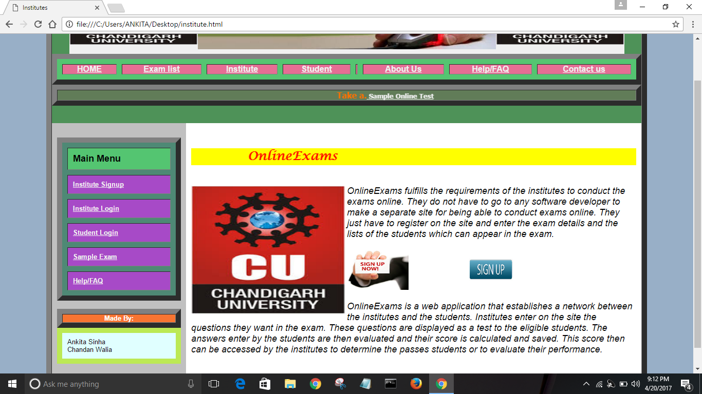

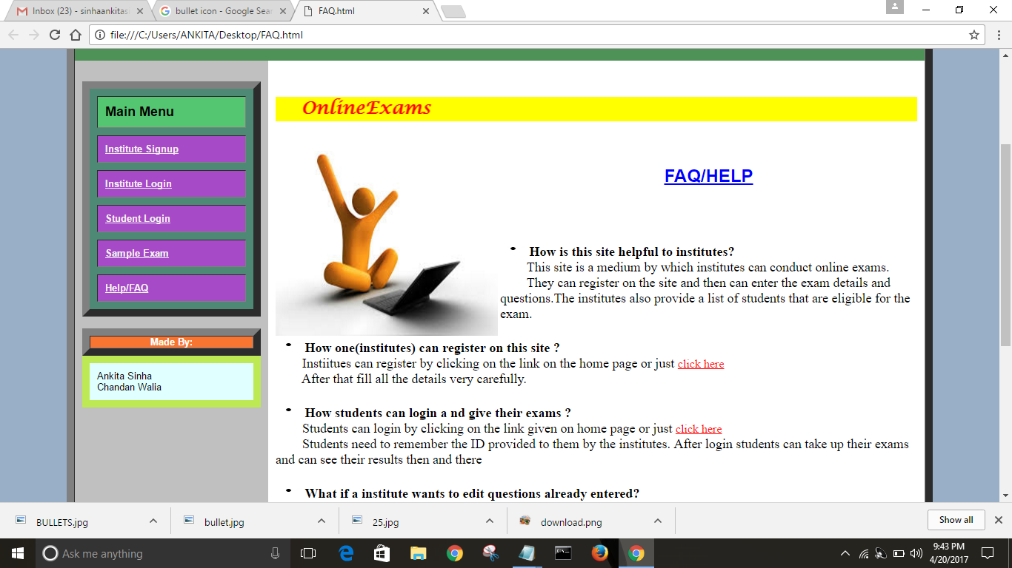

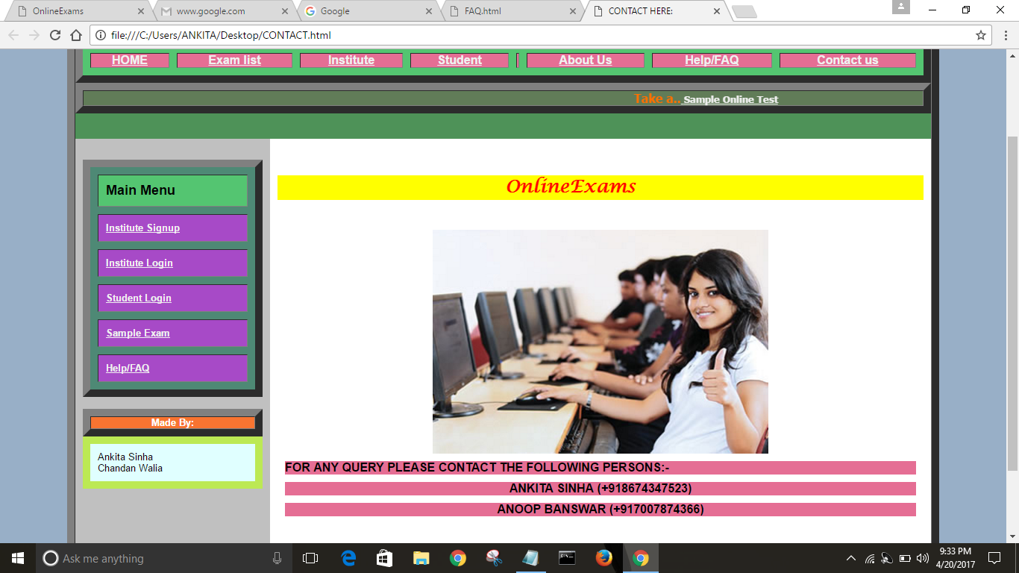

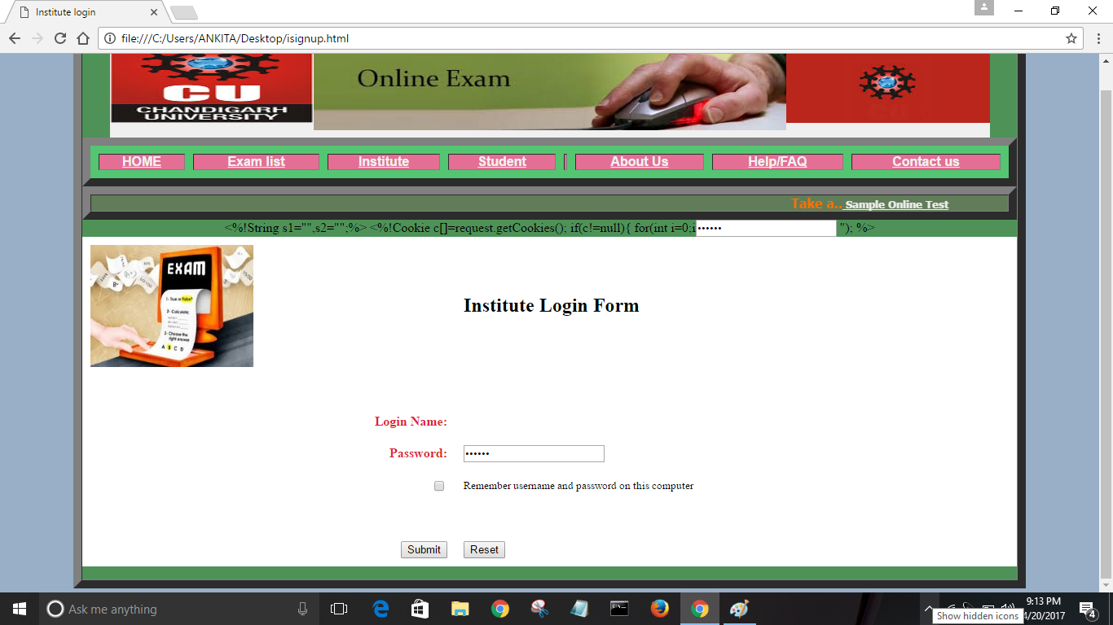



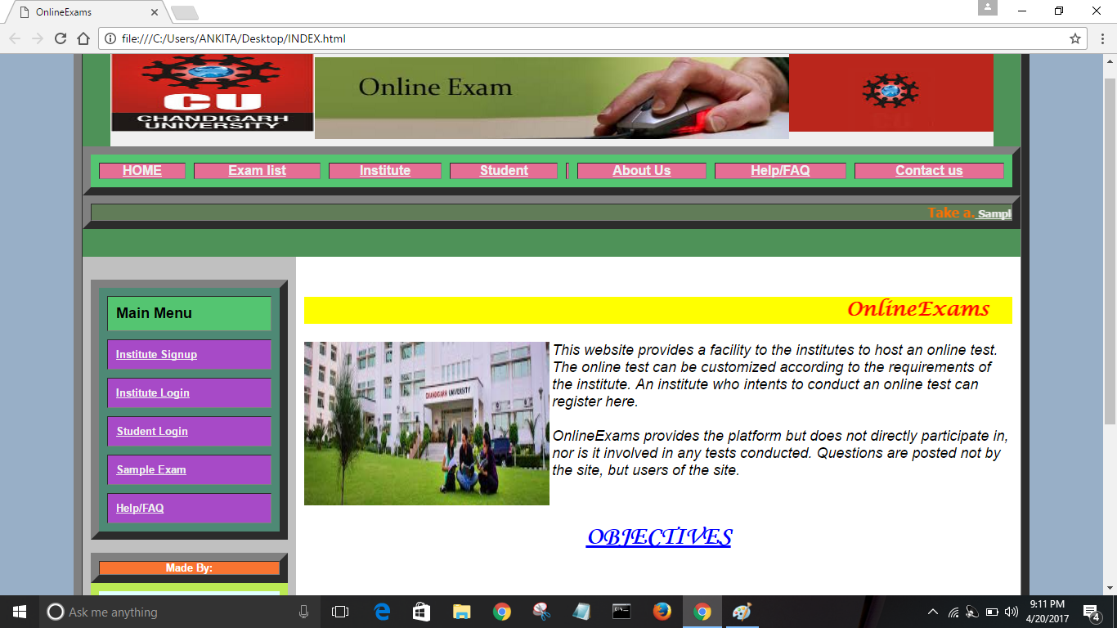

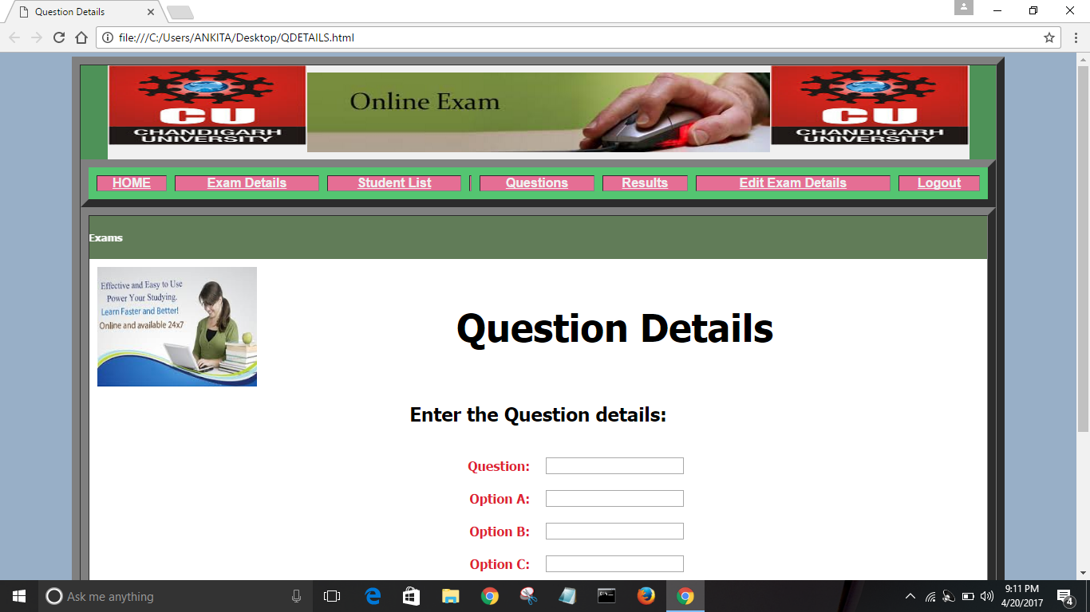

**BIBLIOGRAPHY**

The following books were very helpful during the completion of project:

* Software Engineering By K.K. Aggarwal and Yogesh Singh
* Web Enabled Commercial Appplication Development By Ivan Bayross
* Head First Servlets and JSP By Bryan Basham,Kathy Sierra and Bert Bates
* <https://www.freelancer.ph/online-examination-system-project/>
* https://www.google.co.in/?gfe_rd=cr&ei=gXn5WIypFePy8AfGv7PoCQ&gws_rd=ssl#q=online+examination+system